THEMIS: A Mutually Verifiable Billing System

for the Cloud Computing Environment

**Modules**

* User Interface Design
* Cloud Service Provider
* User

**Module Description**

**User Interface Design**

User Interface Design have a purpose that a user to move from login page to user page of the website. In this we want to enter our user name and password provided by Service provider. If we enter the valid password and user name then only the user can move login page to user window while entering user name and password it will check username and password is match or not. If we enter any wrong username or wrong password it generates some error message. So we are preventing from unauthorized user entering into the service provider website. It will provide a good security for our project. So Service provider contain user name and password server also check the authentication of the user. It will improve the security and preventing from unauthorized user enters into the website. In our project we are using java swings for creating design. Here we are validating the users who are going to access the Service providers.

**Cloud** **Service Provider**

Service provider has a job of providing a service like software to the cloud users. In our proposed method, CSP doesn’t provide billing transaction to the user. It is due to the reason if billing transaction performed in the CSP then complexity in security to be provided for billing transaction increases the overhead. If the user logged in for service, CSP validate the user whether he\she is an authenticated user or not. Once if user is found authenticated user then it waits for service check in message else it found any unauthenticated user it will send the error message. If it received the service check in message then it responds the user by transmitting the agreement and hash chain (one time key). After getting the service request from the user, CSP provide the requested service to the user. It is also have a contact with the Cloud notary authority. It will provide the service until it receive the service checkout message. The CSP enables users to scale their capacity upwards or downwards regarding their computing requirements and to pay only for the capacity that they actually use.

**User**

User can access a service from the Cloud Service Provider by authenticated login process. We assume that users are thin clients who use services in the cloud computing environment. To start a service session in such an environment, each user makes a service check-in request to the CSP with a billing transaction. To end the service session, the user can make a service check-out request to the CSP with a billing transaction. Once if the users send the service check-in message it can get the contract from the CSP. After receiving the one time keywords in the contract it can be able to access the service from the CSP. Now user log details are stored in Monitor for future disputes. After accessing the service, user want billing transaction. If he\she wants the bill means it should send the contract of the CSP with contract of the user to the CNA. If both the details checked by the CNA are identical then user can receive the bill binding information along with confirmation message. If any error occurred or forgery activity found from the user side then the user will receive the penalty for that.

**MODULE DIAGRAM:**

**User Interface Design**

USER

Cloud Service Provider

LOGIN

Client Account page

Validation

Database

**Cloud** **Service Provider**

**CSP**

USER

Check in

Contract + Hash chain

Software services

User details

Service details

Database

**User**

**USER**

CSP Details

CNA Details

Service logs

SLA Detail

**CSP**

CHECK IN

**CNA**

Contract of CSP + USER

**IMPLEMENTAION**

**User Interface Design**

<!DOCTYPE html PUBLIC "-//W3C//DTD XHTML 1.0 Transitional//EN" "http://www.w3.org/TR/xhtml1/DTD/xhtml1-transitional.dtd">

<html xmlns="http://www.w3.org/1999/xhtml">

<head>

<title>Cloud Service Provider</title>

<meta http-equiv="Content-Type" content="text/html; charset=utf-8" />

<link href="css/style.css" rel="stylesheet" type="text/css" />

<link rel="stylesheet" type="text/css" href="css/coin-slider.css" />

<script type="text/javascript" src="js/cufon-yui.js"></script>

<script type="text/javascript" src="js/droid_sans_400-droid_sans_700.font.js"></script>

<script type="text/javascript" src="js/jquery-1.4.2.min.js"></script>

<script type="text/javascript" src="js/script.js"></script>

<script type="text/javascript" src="js/coin-slider.min.js"></script>

<script type="text/javascript" src="Validation.js"></script>

<link rel="stylesheet" type="text/css" href="style.css" media="screen" />

</head>

<body>

</script>

<script language="javascript">

function validate_register()

{

var a=document.getElementById("name");

var b=document.getElementById("password");

var c=document.getElementById("uname");

var d=document.getElementById("rpass");

var e=document.getElementById("phone");

var f=document.getElementById("email");

var g=document.getElementById("addr");

var h=document.getElementById("acc");

var n=e.value.length;

var ac=h.value.length;

var em=f.value;

var a1=em.indexOf("@");

var b1=em.indexOf(".");

var numbers = /^[0-9]+$/;

if(a.value=="")

{

alert("Enter the Name");

a.focus();

return false;

}

else if(c.value=="")

{

alert("Enter the Username");

c.focus();

return false;

}

else if(b.value=="")

{

alert("Enter the Password");

b.focus();

return false;

}

else if(d.value=="")

{

alert("Enter the Confirm Password");

d.focus();

return false;

}

else if(d.value!=b.value)

{

alert("MisMatch Password");

d.focus();

return false;

}

else if(d.value.length!=6||b.value.length!=6)

{

alert("Password must contains 6 character");

d.focus();

return false;

}

else if(e.value=="")

{

alert("Enter the Phone Number");

e.focus();

return false;

}

else if(n!=10)

{

alert("Enter the 10 Character Phone Number");

e.focus();

return false;

}

else if(!e.value.match(numbers))

{

alert(numbers);

alert("Phone Number must be Number");

e.focus();

return false;

}

else if(f.value=="")

{

alert("Enter the Email");

f.focus();

return false;

}

else if(a1>b||a1==-1||b1==-1)

{

alert("Enter the Proper MailID");

f.focus();

return false;

}

else if(g.value=="")

{

alert("Enter the Address");

g.focus();

return false;

}

else if(h.value=="")

{

alert("Enter the Account Number");

h.focus();

return false;

}

else if(!h.value.match(numbers))

{

alert(numbers);

alert("Phone Number must be Number");

e.focus();

return false;

}

else if(ac<7)

{

alert("Account Number must be contains Above 7 Characters");

h.focus();

return false;

}

}

</script>

<div class="main">

<div class="header">

<div class="header_resize">

<div class="searchform">

<div class="top_menu"> </div>

</div>

<div class="logo">

<h1><a href="#">Cloud<span>Service Provider</span></a></h1>

</div>

<div class="clr"></div>

<div class="menu_nav">

<ul>

<li class="active"><a href="Home.jsp"><span>Home Page</span></a></li>

<li><a href="support.jsp"><span>Support</span></a></li>

<li><a href="about.jsp"><span>About Us</span></a></li>

<li><a href="contact.jsp"><span>Contact Us</span></a></li>

</ul>

</div>

<div class="clr"></div>

<div class="slider">

<div id="coin-slider">

<a href="#"><img src="images/slide1.jpg" width="960" height="360" alt="" />

<span>

<big>

Billing System

</big>

<div class="clr"></div>

</div>

<div class="clr"></div>

</div>

</div>

<div class="content">

<div class="content_resize">

<div class="mainbar">

<div class="article">

<h2><span>Excellent Solution</span> For Your Billing System</h2>

<div class="clr"></div>

<div class="img"><img src="images/img1.jpg" width="236" height="245" alt="" class="fl" /></div>

<div class="post_content">

<p><br/>

We built a billing management system that allows you to worry about building your business, not your billing system. Chargify can help you: <br/><br/>

<img src="images/checked.gif">Charge your customers’ credit cards securely<br/>

<img src="images/checked.gif">Get real-time insight into orders & revenue<br/>

<img src="images/checked.gif">Manage the dunning process when cards fail<br/>

<img src="images/checked.gif">Handle free trials, promotions, refunds & more<br/>

<img src="images/checked.gif">Charge customers on a per-usage basis<br/>

</p>

</div>

</div>

</div>

<div class="sidebar">

<div class="gadget">

<h2 class="star"><span></span>Registration</h2>

<div class="clr"></div>

<ul class="sb_menu">

<table>

<tr>

<br/>

</tr>

<tr>

<td>

Name

</td>

<td>

<input type="text" id="name" name="username"/>

</td>

</tr>

<tr>

<td>

Username

</td>

<td>

<input type="text" id="uname" name="username"/>

</td>

</tr>

<tr>

<td>

Password

</td>

<td>

<input type="password" id="password" name="password"/>

</td>

</tr>

<tr>

<td>

Confirm Password

</td>

<td>

<input type="password" id="rpass" name="rpassword"/>

</td>

</tr>

<tr>

<td>

Phone Number

</td>

<td>

<input type="text" id="phone" name="password"/>

</td>

</tr>

<tr>

<td>

Email

</td>

<td>

<input type="text" id="email" name="password"/>

</td>

</tr>

<tr>

<td>

Address

</td>

<td>

<textarea name="addr" id="addr"></textarea>

</td>

</tr>

<tr>

<td>

Account Number

</td>

<td>

<input type="password" id="acc" name="acc"/>

</td>

</tr>

<tr>

<td>

<input type="submit" value="Register" onclick="return validate_register()"/>

</td>

</tr>

</table>

</ul>

</div>

</div>

<div class="clr"></div>

</div>

</div>

<div class="fbg">

<div class="fbg_resize">

<div class="col c1">

<h2><span>Image</span> Gallery</h2>

<a href="#"><img src="images/gal1.jpg" width="75" height="75" alt="" class="gal" /></a> <a href="#"><img src="images/gal2.jpg" width="75" height="75" alt="" class="gal" /></a> <a href="#"><img src="images/gal3.jpg" width="75" height="75" alt="" class="gal" /></a> <a href="#"><img src="images/gal4.jpg" width="75" height="75" alt="" class="gal" /></a> <a href="#"><img src="images/gal5.jpg" width="75" height="75" alt="" class="gal" /></a> <a href="#">

<img src="images/gal6.jpg" width="75" height="75" alt="" class="gal" /></a> </div>

<div class="col c2">

<h2><span>Services</span> Overview</h2>

**USER INTERFACE**

**Registration**

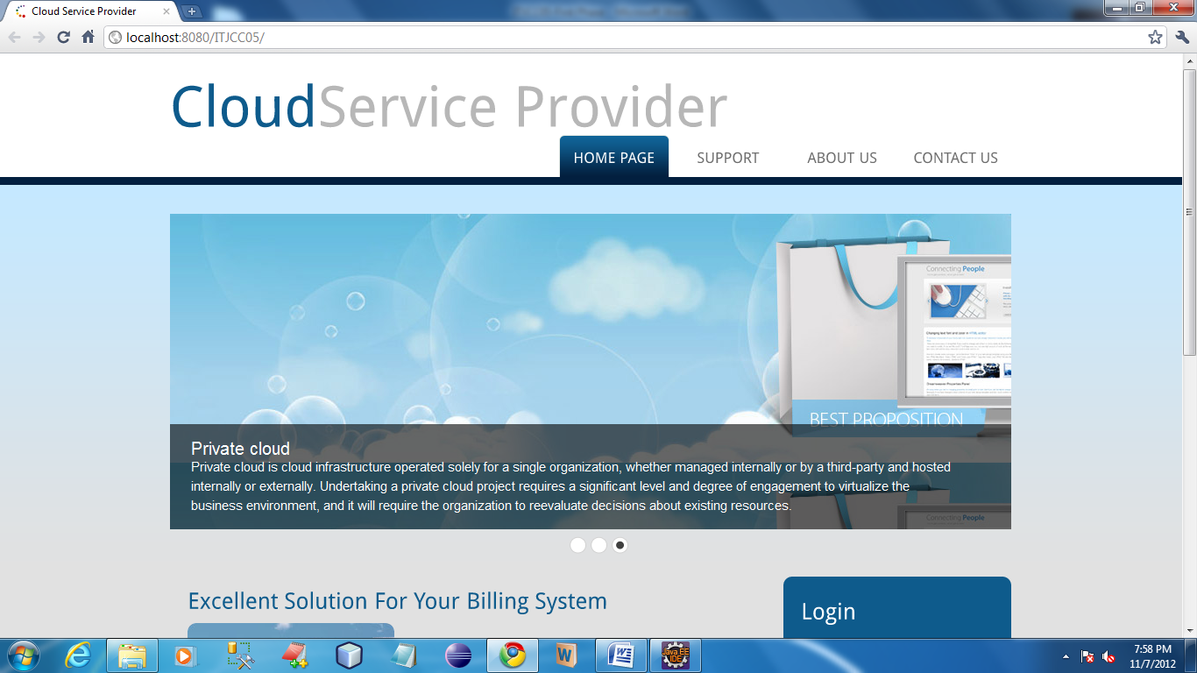

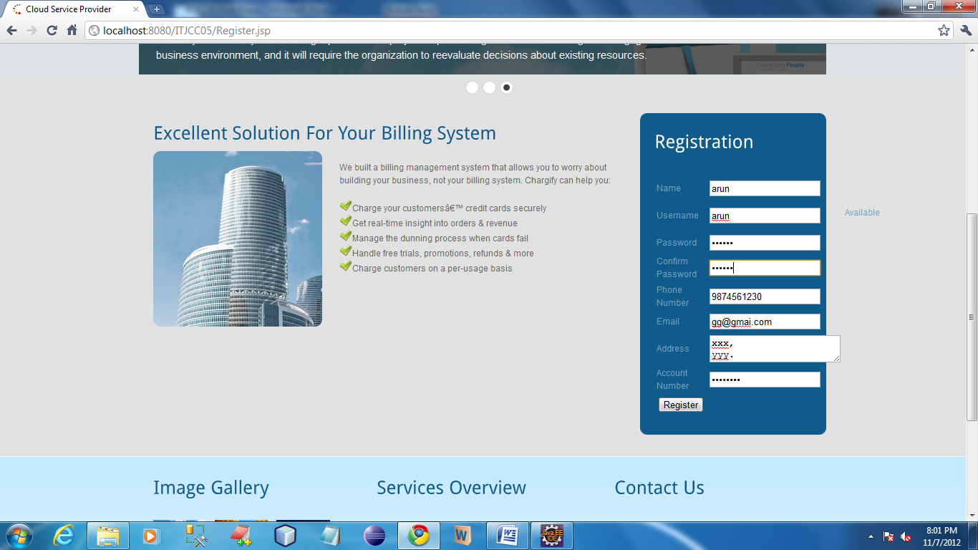

**Cloud Service Provider**

/**

* Servlet implementation class CSP_Homepage

*/

public class CSP_Homepage extends HttpServlet {

private static final long serialVersionUID = 1L;

/**

* @see HttpServlet#HttpServlet()

*/

public CSP_Homepage() {

super();

// TODO Auto-generated constructor stub

}

/**

* @see HttpServlet#doGet(HttpServletRequest request, HttpServletResponse response)

*/

protected void doGet(HttpServletRequest request, HttpServletResponse response) throws ServletException, IOException {

// TODO Auto-generated method stub

}

/**

* @see HttpServlet#doPost(HttpServletRequest request, HttpServletResponse response)

*/

protected void doPost(HttpServletRequest request, HttpServletResponse response) throws ServletException, IOException

{

String admin_name=request.getParameter("username");

String admin_pass=request.getParameter("password");

HttpSession hs=request.getSession();

hs.setAttribute("username", admin_name);

if((admin_name.equalsIgnoreCase("admin"))&&(admin_pass.equalsIgnoreCase("admin")))

{

RequestDispatcher rd= request.getRequestDispatcher("CSP_Homepage.jsp");

rd.forward(request,response);

}

}

}

public class Upload extends HttpServlet {

protected void processRequest(HttpServletRequest request, HttpServletResponse response)

throws ServletException, IOException {

response.setContentType("text/html;charset=UTF-8");

PrintWriter out = response.getWriter();

ServletContext context=getServletContext();

try

{

String contentType = request.getContentType();

System.out.println("content type "+contentType);

if ((contentType != null) && (contentType.indexOf("multipart/form-data") >= 0)) {

DataInputStream in = new DataInputStream(request.getInputStream());

//we are taking the length of Content type data

int formDataLength = request.getContentLength();

byte dataBytes[] = new byte[formDataLength];

int byteRead = 0;

int totalBytesRead = 0;

//this loop converting the uploaded file into byte code

while (totalBytesRead < formDataLength)

{

byteRead = in.read(dataBytes, totalBytesRead, formDataLength);

totalBytesRead += byteRead;

}

fileSize=dataBytes.length;

String file = new String(dataBytes);

//for saving the file name

// System.out.println("file is nnnnnnnnnnn="+file+"xxxxxxxxxxxxxxx");

String saveFile = file.substring(file.indexOf("filename=\"") + 10);

// System.out.println("save file is "+file);

saveFile = saveFile.substring(0, saveFile.indexOf("\n"));

saveFile = saveFile.substring(saveFile.lastIndexOf("\\") + 1, saveFile.indexOf("\""));

int lastIndex = contentType.lastIndexOf("=");

String boundary = contentType.substring(lastIndex + 1, contentType.length());

int pos;

//extracting the index of file

pos = file.indexOf("filename=\"");

pos = file.indexOf("\n", pos) + 1;

pos = file.indexOf("\n", pos) + 1;

pos = file.indexOf("\n", pos) + 1;

int boundaryLocation = file.indexOf(boundary, pos) - 4;

int startPos = ((file.substring(0, pos)).getBytes()).length;

int endPos = ((file.substring(0, boundaryLocation)).getBytes()).length;

String path = request.getRealPath("");

System.out.println("path="+path);

System.out.println("saved name is"+saveFile);

String uploadedfile=context.getInitParameter("uploadedpath");

FileOutputStream fileOut = new FileOutputStream(uploadedfile+"\\"+saveFile);

fileOut.write(dataBytes, startPos, (endPos - startPos));

fileOut.flush();

fileOut.close();

HttpSession hs=request.getSession();

hs.setAttribute("filename", saveFile);

// al=(ArrayList)PublicDBClass.singleton().getFileNames(UserName);

// hs.setAttribute("filenames",al);

RequestDispatcher rdp=request.getRequestDispatcher("AfterUpload.jsp");

rdp.forward(request, response);

}

else

{

System.out.println("file not uploaded");

}

String ContentType;

byte[] b;

} finally {

out.close();

}

}

// <editor-fold defaultstate="collapsed" desc="HttpServlet methods. Click on the + sign on the left to edit the code.">

@Override

protected void doGet(HttpServletRequest request, HttpServletResponse response)

throws ServletException, IOException {

processRequest(request, response);

}

@Override

protected void doPost(HttpServletRequest request, HttpServletResponse response)

throws ServletException, IOException {

processRequest(request, response);

}

@Override

public String getServletInfo() {

return "Short description";

}// </editor-fold>

Connection con;

Statement st;

int fileSize;

String UserName;

ArrayList al;

}

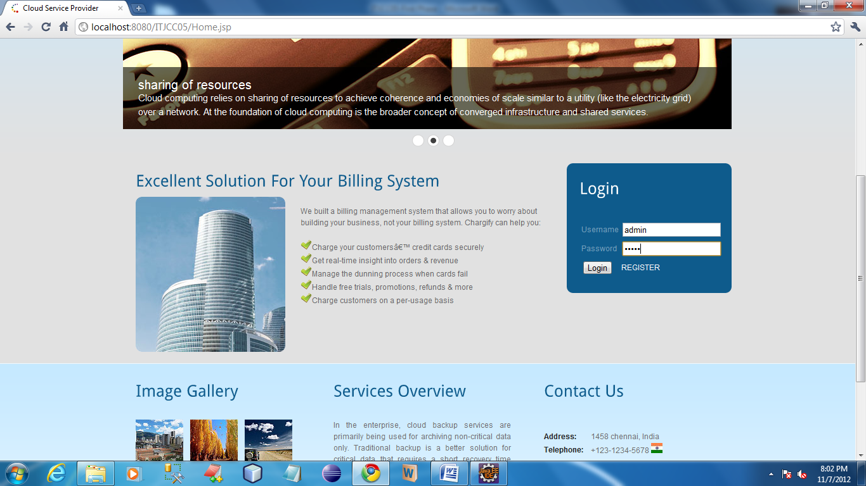

CSP login their account by using the username and password as admin and admin respectively. Once authentication finished it shows the homepage for CSP.

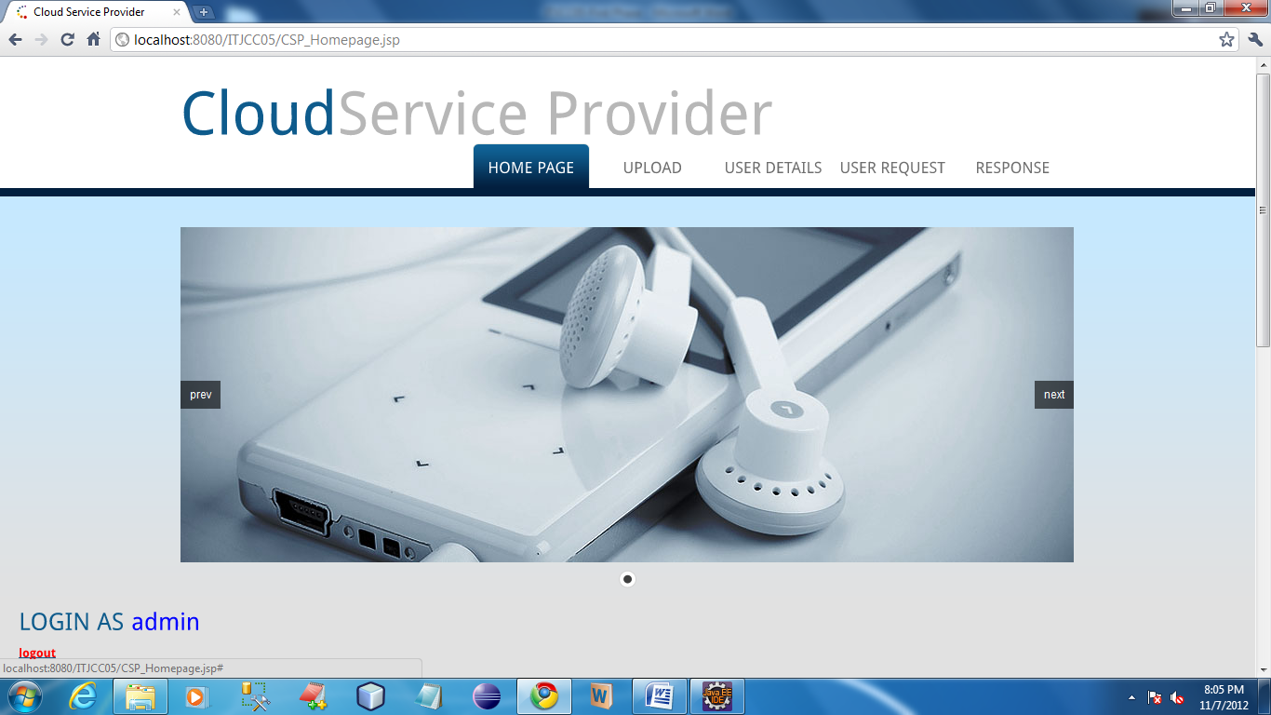

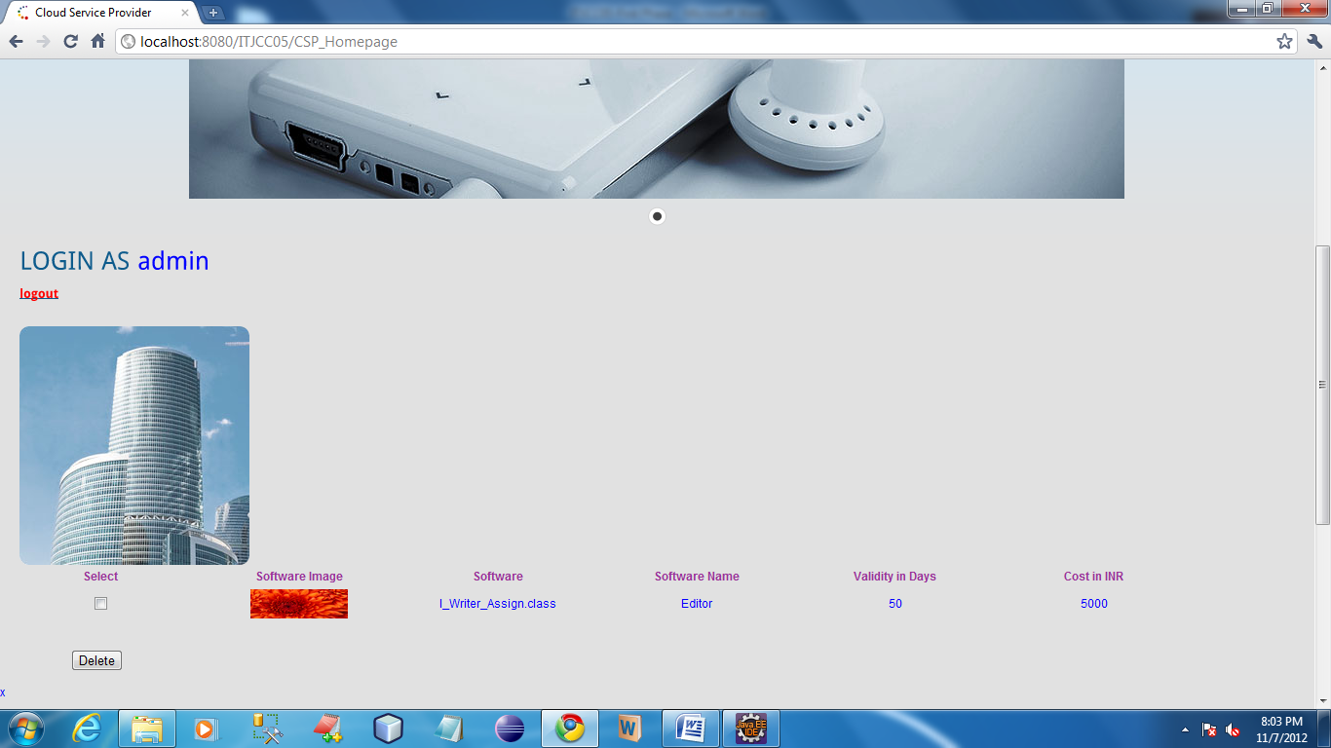

In CSP homepage all the service details can be viewed by admin.

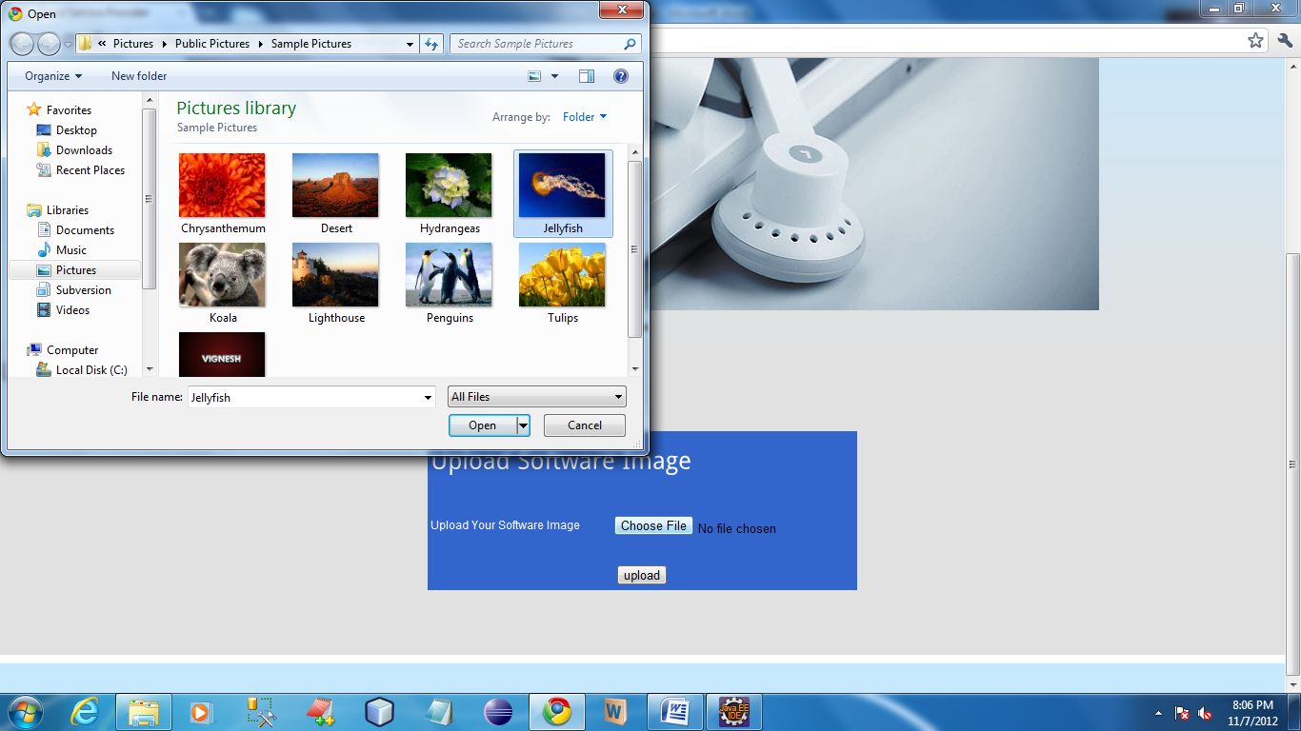

In this page admin can upload software image.

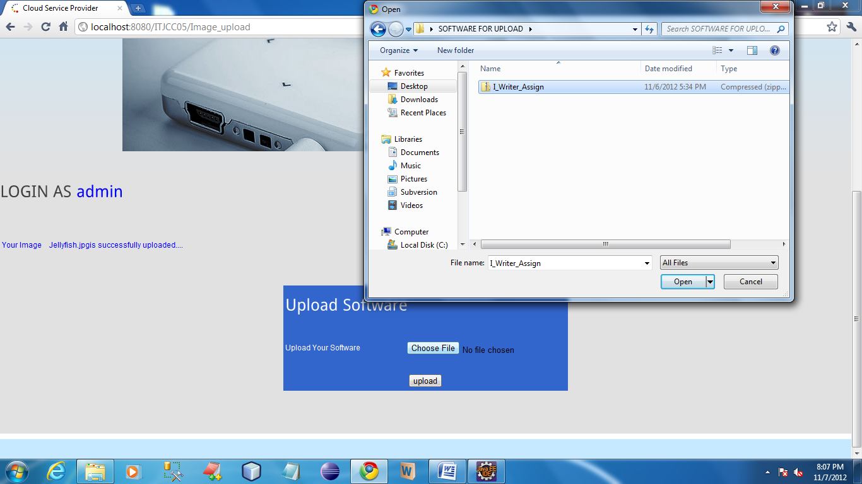

In this page user can upload their softwares which will be going to give as a service for the users.

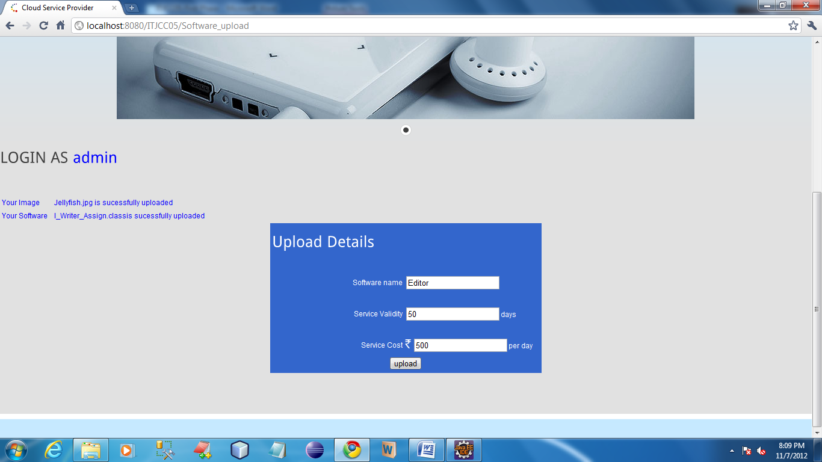

In this page admin can upload the details about software.

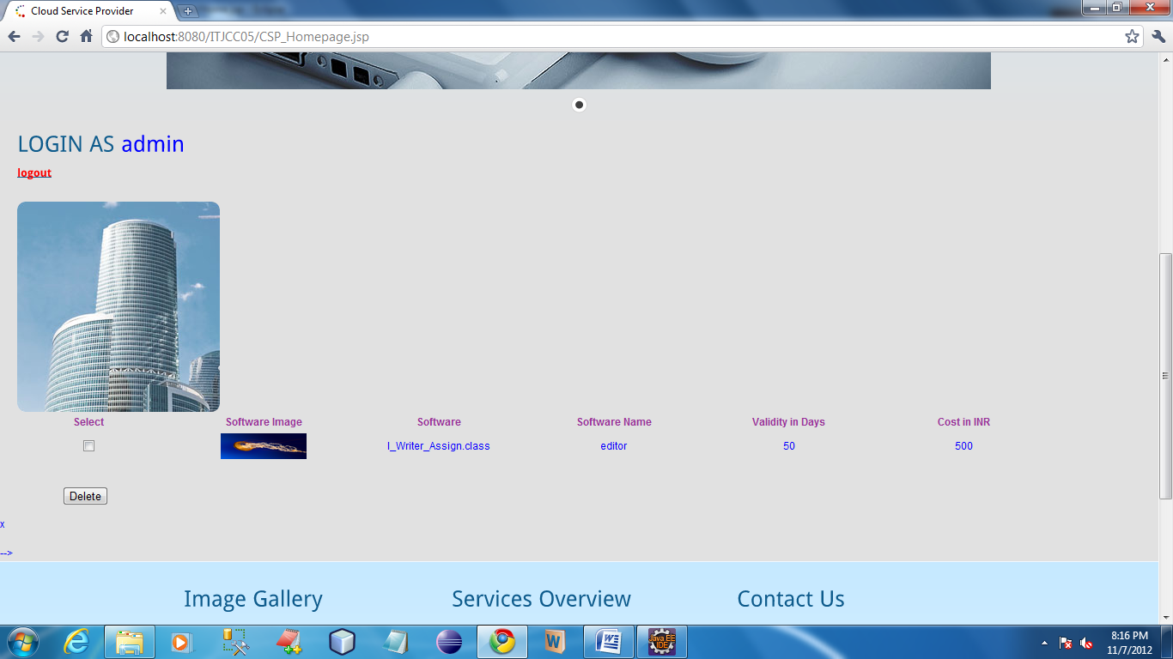

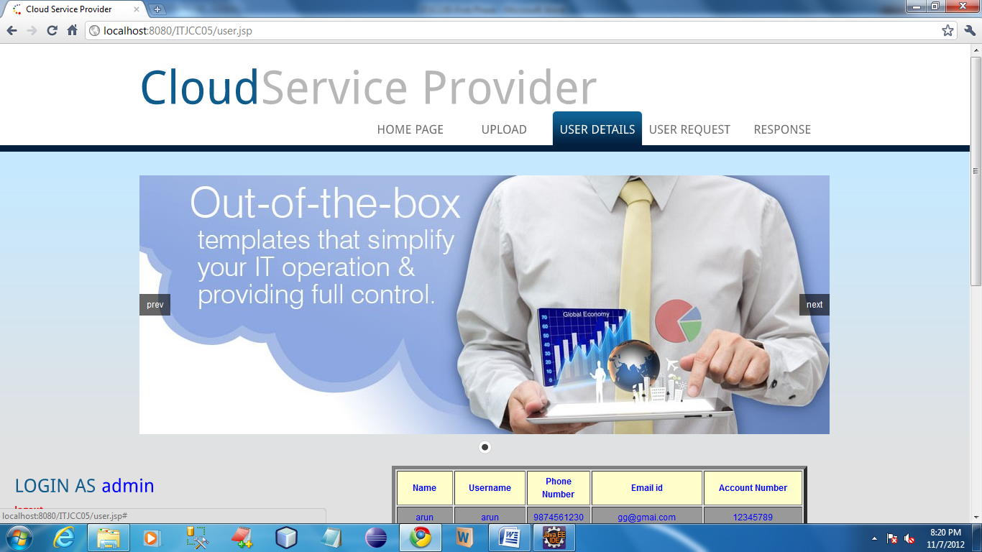

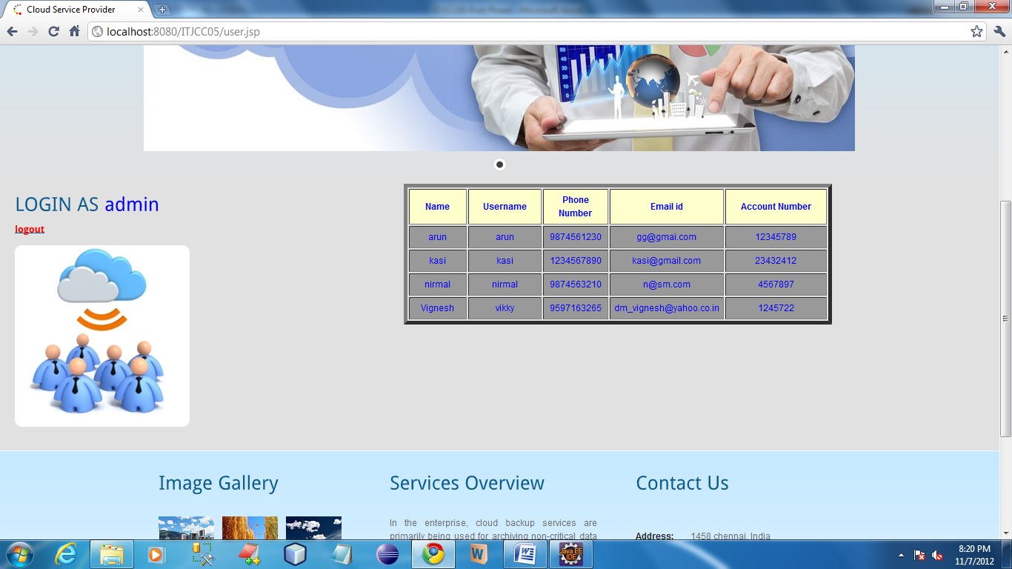

In this page admin can view their registered users who are access their service.

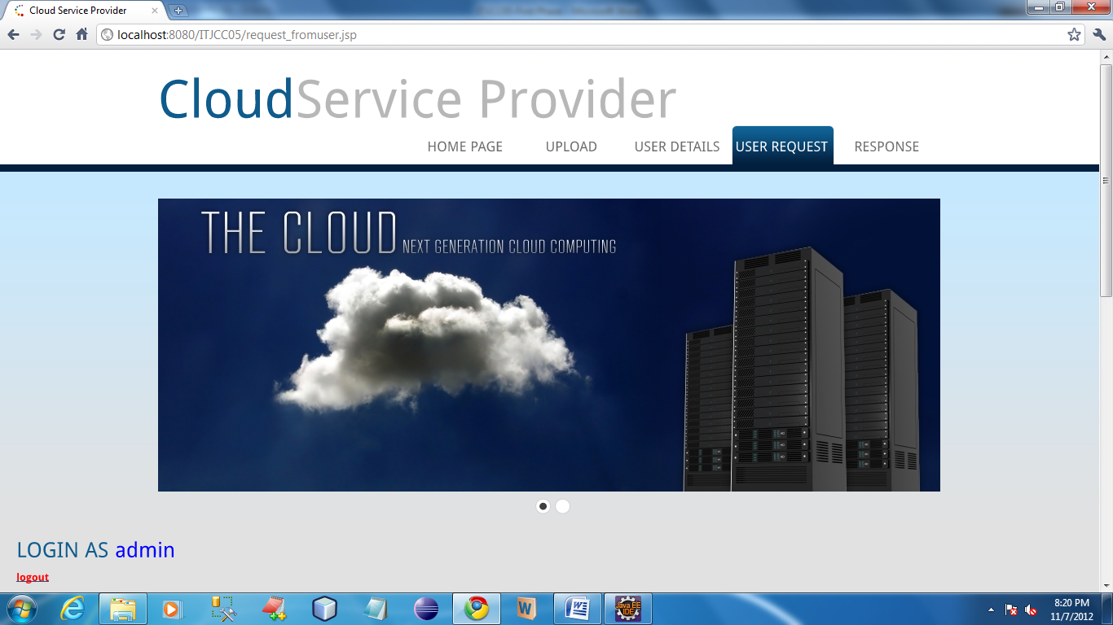

**User**

<!DOCTYPE html PUBLIC "-//W3C//DTD XHTML 1.0 Transitional//EN" "http://www.w3.org/TR/xhtml1/DTD/xhtml1-transitional.dtd">

<html xmlns="http://www.w3.org/1999/xhtml">

<head>

<title>Cloud Service Provider</title>

<meta http-equiv="Content-Type" content="text/html; charset=utf-8" />

<link href="css/style.css" rel="stylesheet" type="text/css" />

<link rel="stylesheet" type="text/css" href="css/coin-slider.css" />

<script type="text/javascript" src="js/cufon-yui.js"></script>

<script type="text/javascript" src="js/droid_sans_400-droid_sans_700.font.js"></script>

<script type="text/javascript" src="js/jquery-1.4.2.min.js"></script>

<script type="text/javascript" src="js/script.js"></script>

<script type="text/javascript" src="js/coin-slider.min.js"></script>

<link rel="stylesheet" type="text/css" href="style.css" media="screen" />

</head>

<body>

<script language="javascript">

function validate()

{

var a=document.getElementById("name");

var b=document.getElementById("pass");

if(a.value=="")

{

alert("Enter the Username");

a.focus();

return false;

}

else if(b.value=="")

{

alert("Enter the Password");

b.focus();

return false;

}

}

</script>

<div class="main">

<div class="header">

<div class="header_resize">

<div class="searchform">

<div class="top_menu"> </div>

</div>

<div class="logo">

<h1><a href="#">Cloud<span>Service Provider</span></a></h1>

</div>

<div class="clr"></div>

<div class="menu_nav">

<ul>

<li class="active"><a href="Home.jsp"><span>Home Page</span></a></li>

<li><a href="support.jsp"><span>Support</span></a></li>

<li><a href="about.jsp"><span>About Us</span></a></li>

<li><a href="contact.jsp"><span>Contact Us</span></a></li>

</ul>

</div>

<div class="clr"></div>

<div class="slider">

<div id="coin-slider">

<a href="#"><img src="images/slide1.jpg" width="960" height="360" alt="" />

<span>

<div class="sidebar">

<div class="gadget">

<h2 class="star"><span></span>Login</h2>

<div class="clr"></div>

<ul class="sb_menu">

<form name="form" method="post" action="CSP_Homepage" >

<table>

<tr>

<br/>

</tr>

<tr>

<td>

Username

</td>

<td>

<input type="text" id="name" name="username"/>

</td>

</tr>

<tr>

<td>

Password

</td>

<td>

<input type="password" id="pass" name="password"/>

</td>

</tr>

<tr>

<td>

<input type="submit" value="Login" onclick="return validate()"/>

</td>

<td>

<a href="Register.jsp"><font color="white">REGISTER</font></a>

</td>

</tr>

</table>

</ul>

</div>

</div>

<div class="clr"></div>

</div>

</div>

<div class="fbg">

<div class="fbg_resize">

<div class="col c1"> <ul class="fbg_ul">

<li><a href="http://en.wikipedia.org/wiki/Cloud_computing">Cloud Computing</a></li>

<li><a href="http://searchdatabackup.techtarget.com/definition/cloud-backup">cloud backup</a></li>

<li><a href="http://searchcloudcomputing.techtarget.com/definition/cloud-computing">Hybrid cloud.</a></li>

</ul>

</div>

<div class="col c3">

<h2><span>Contact</span> Us</h2>

<p></p>

<p class="contact_info"> <span>Address:</span>1458 chennai, India<br />

<span>Telephone:</span> +123-1234-5678 <img src="images/images (1).jpg" width="18" height="16" alt="" /><br />

<span>FAX:</span> +458-4578<br />

<span>Others:</span> +301 - 0125 - 01258<br />

<span>E-mail:</span> <a href="#">abc@cloud.com</a> </p>

</div>

<div class="clr"></div>

</div>

</div>

<div class="footer">

<div class="footer_resize">

<div style="clear:both;"></div>

</div>

</div>

</div>

<div align=center></div></body>

</html>

**User**

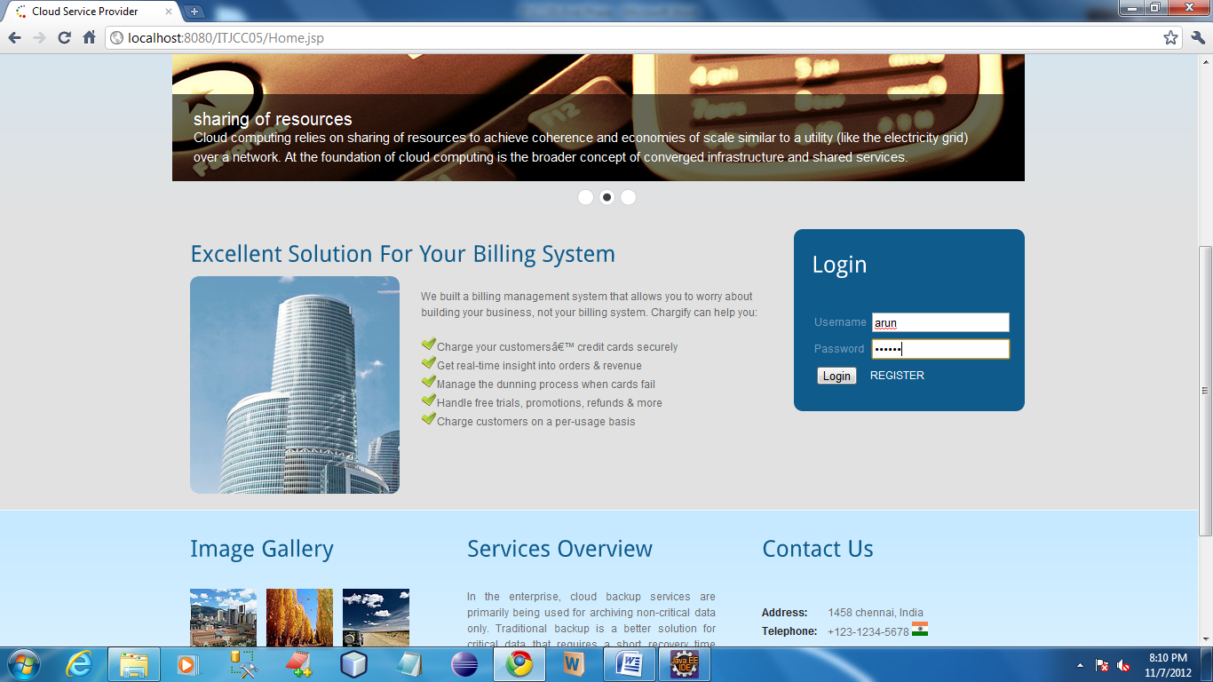

In this page user can log in by using the registered username and password. Once user authenticated by the server user homepage will open.

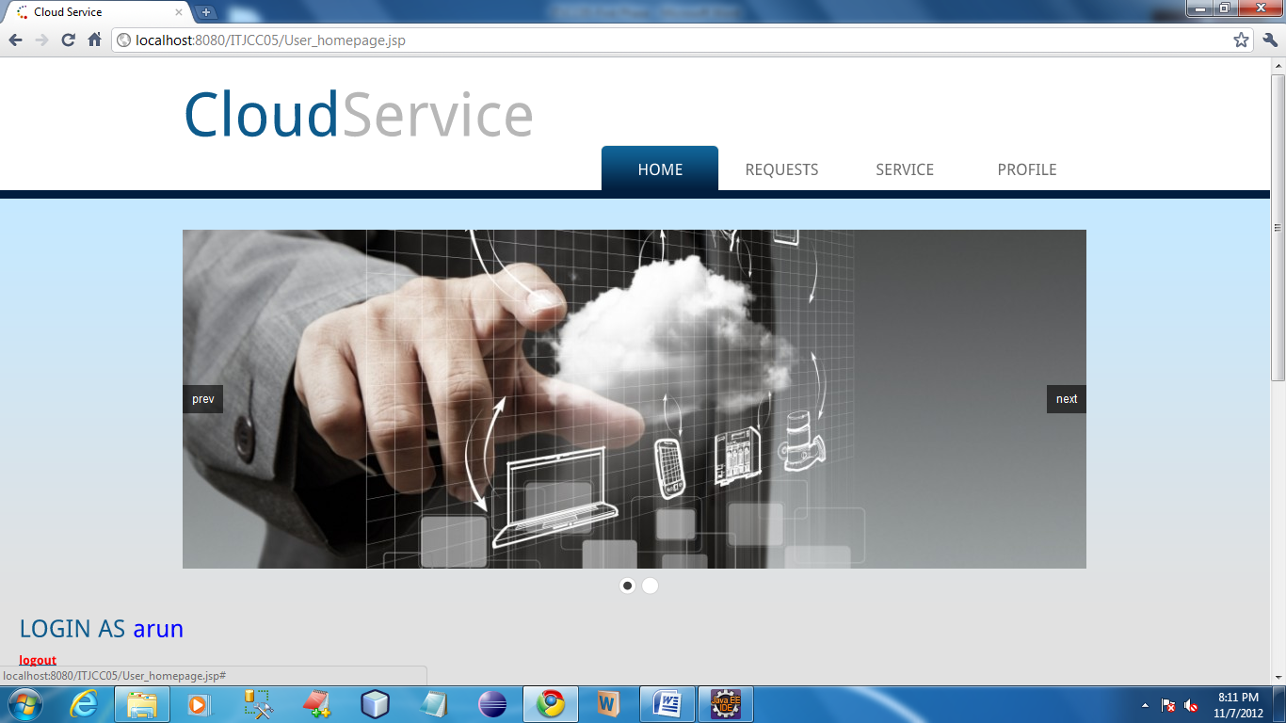

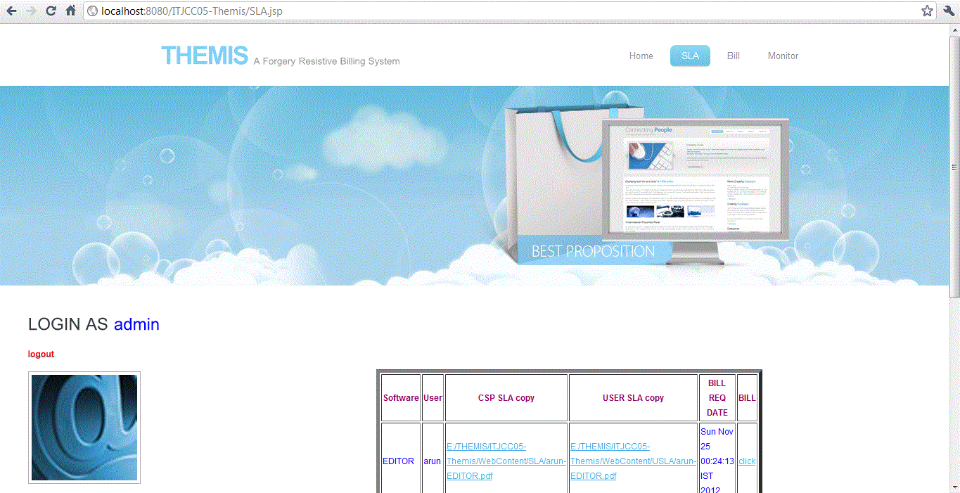

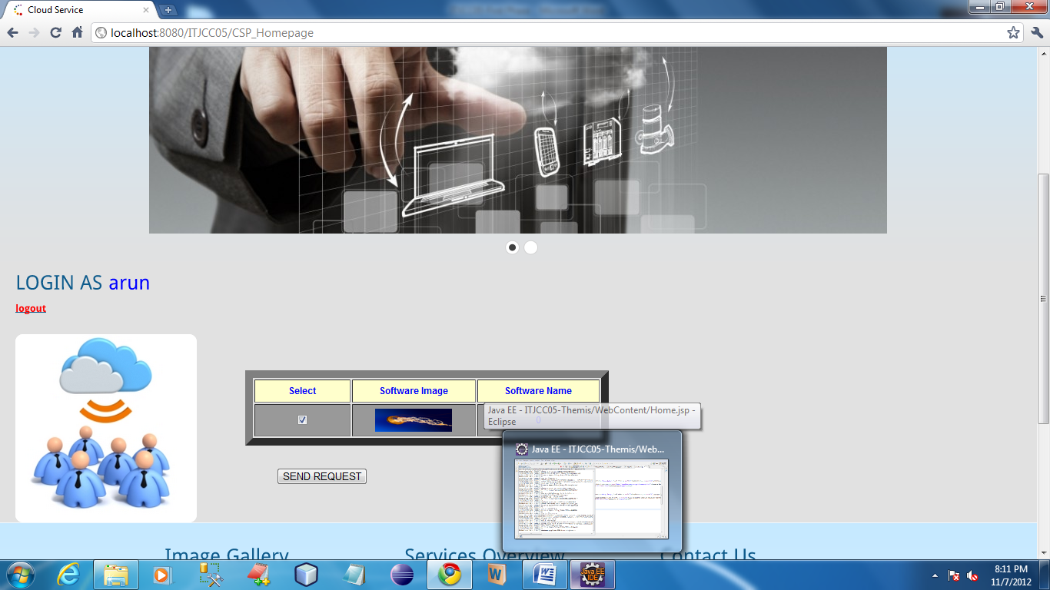

In this page user can view the services which was given by the CSP. In this page user can send the request to the CSP by selecting the available software.

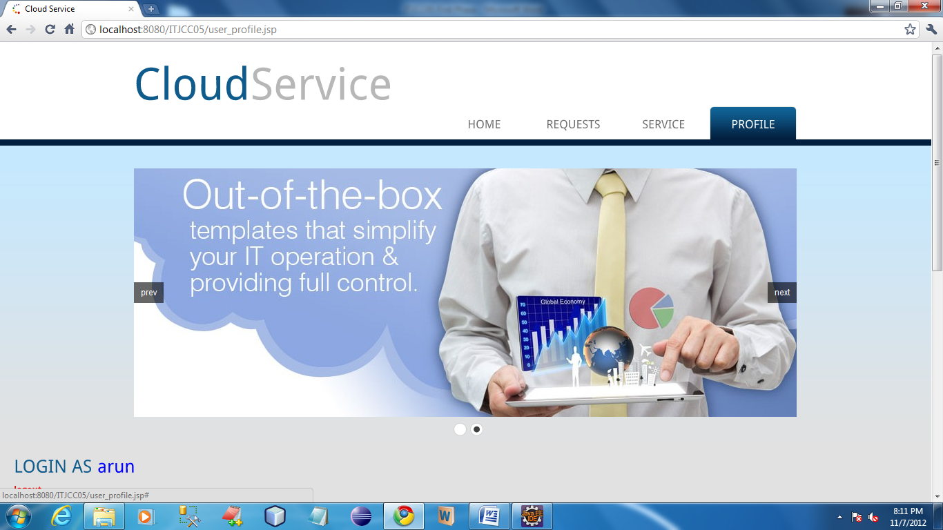

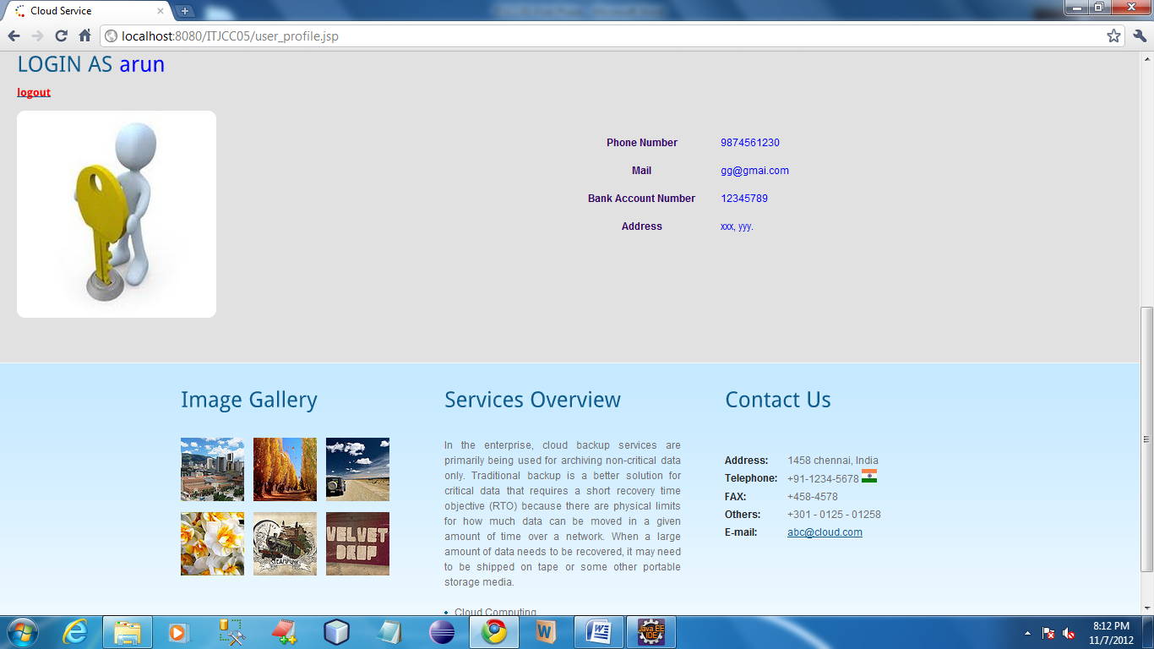

In this page user can view their profile details which was given at the time of registration.

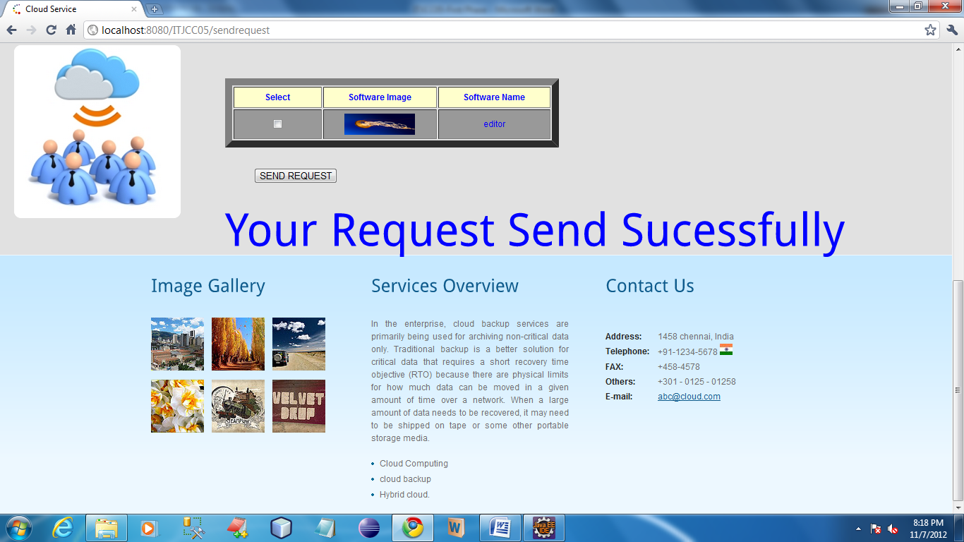

Once user send the request to the CSP, then the success message will be open.

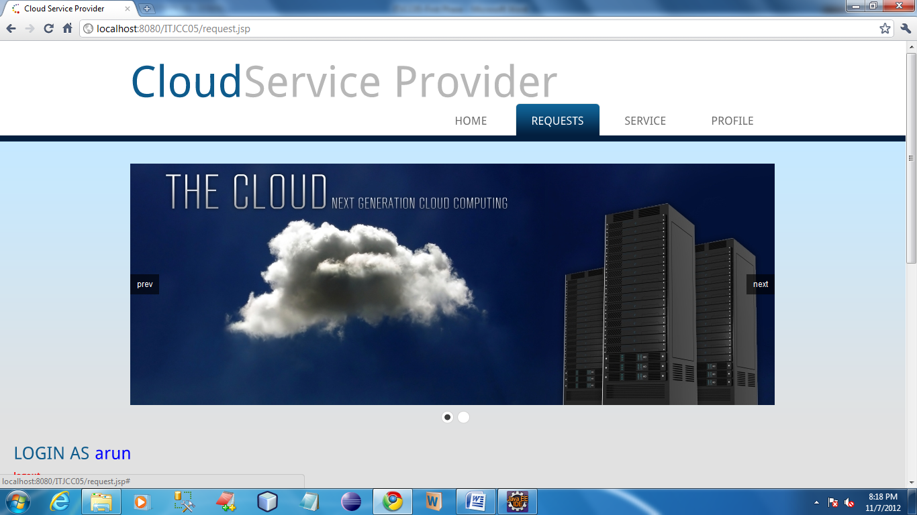

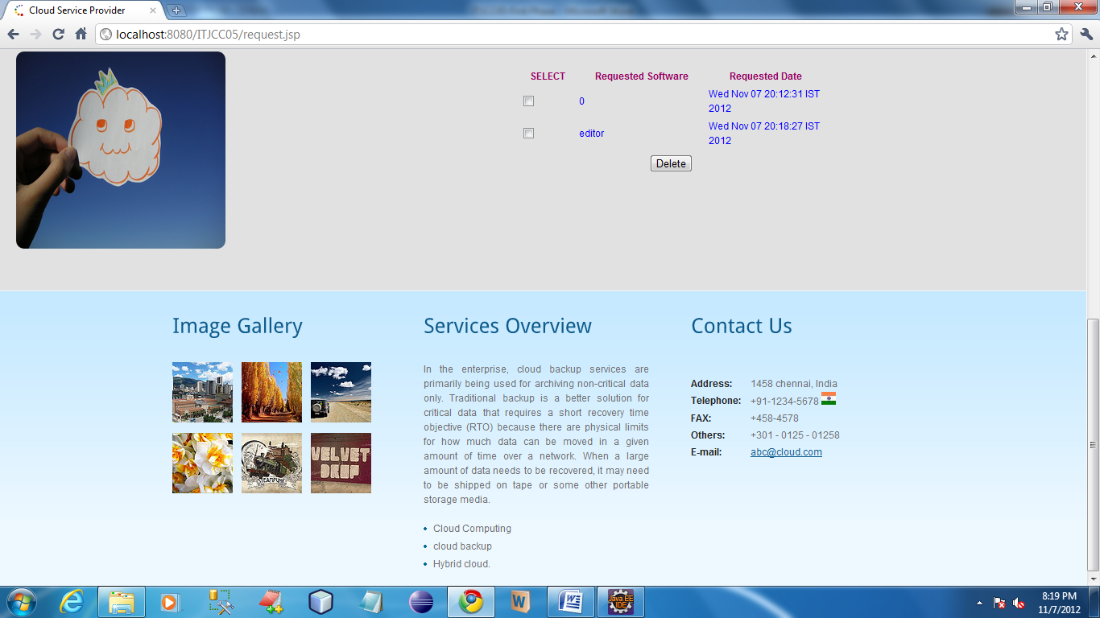

In this page user can view the log details of request which was send to the CSP.

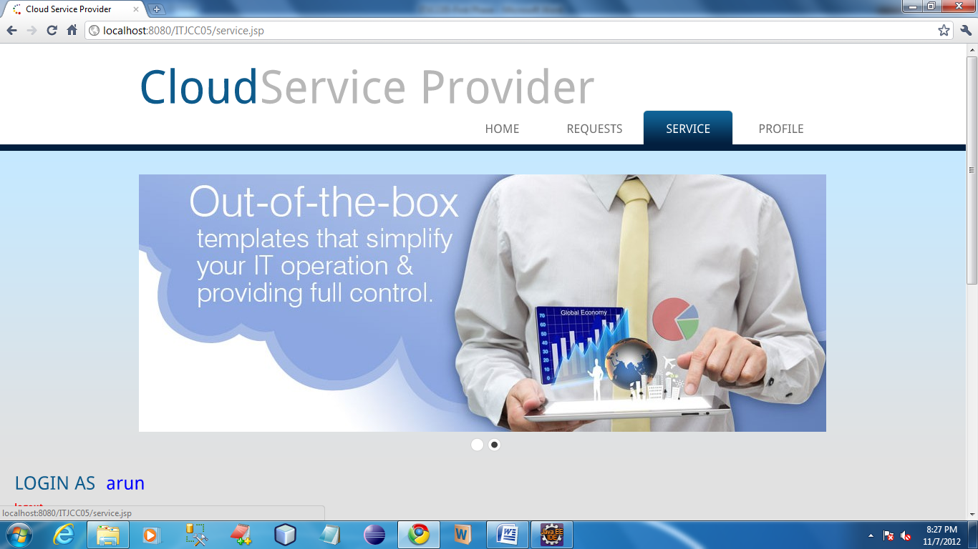

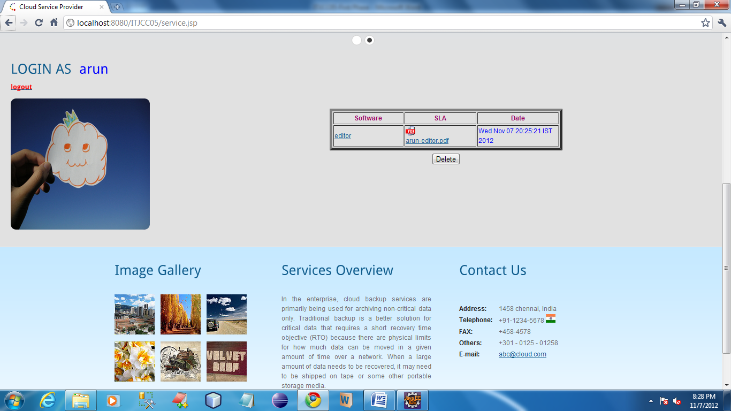

In this page user can download the SLA which was send by the CSP.

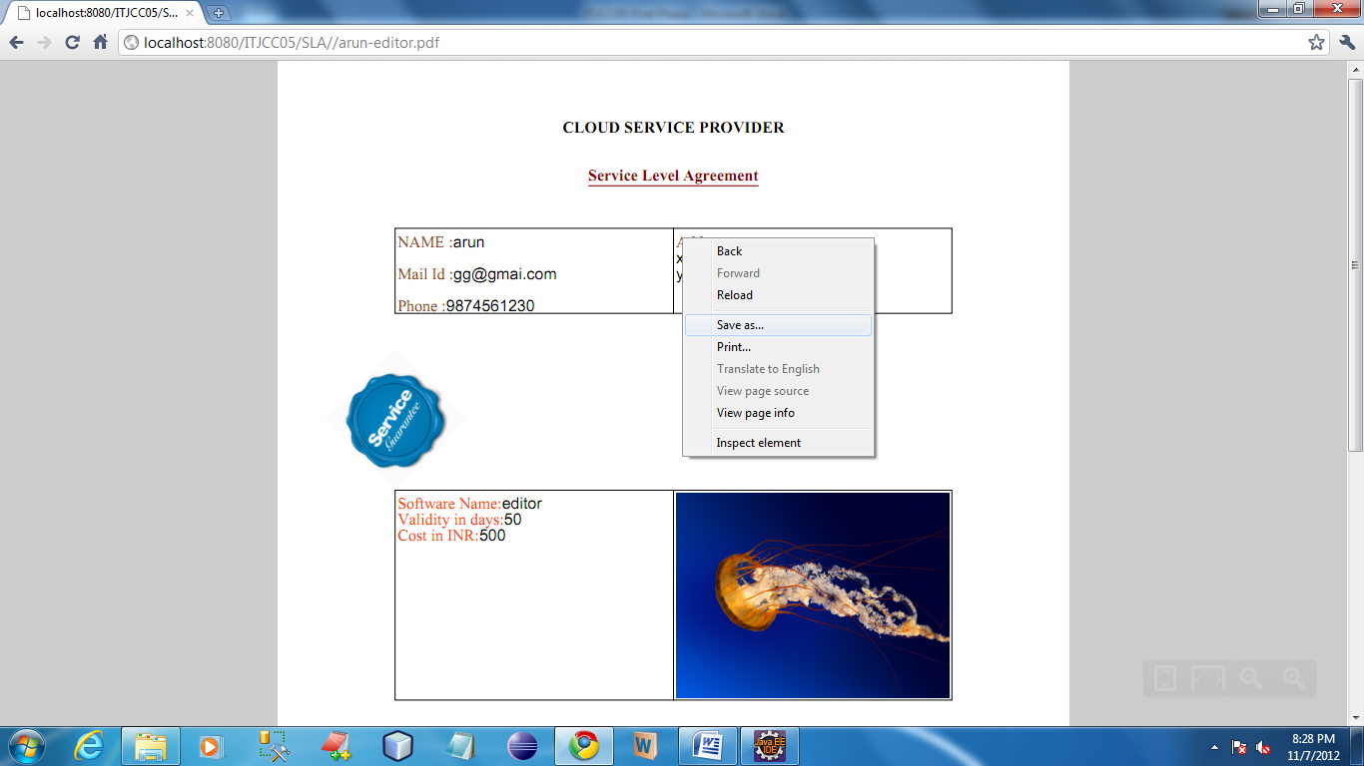

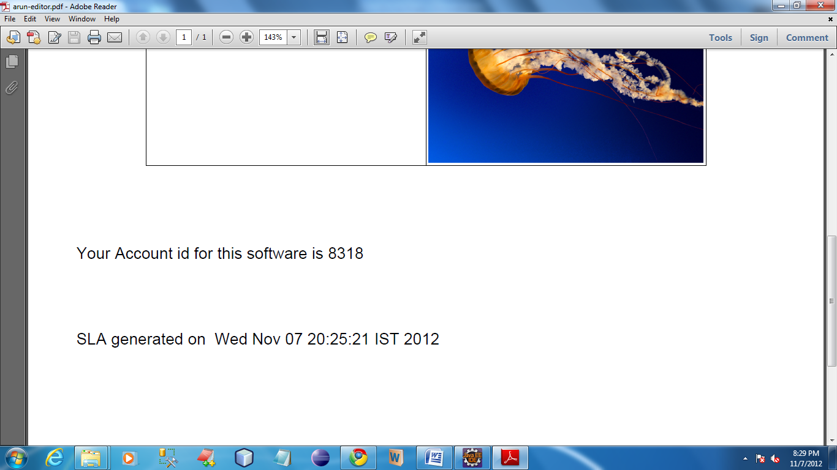

From the SLA user can get the onetime password. By using this password user can access the service.

In this page user should enter their account id for accessing the service.

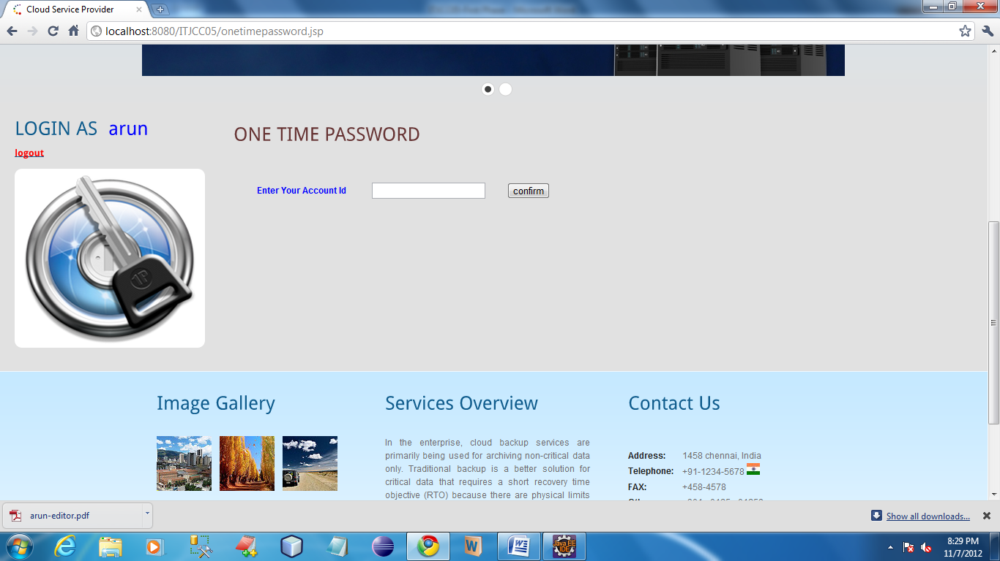

After entering onetime password it show service page as below

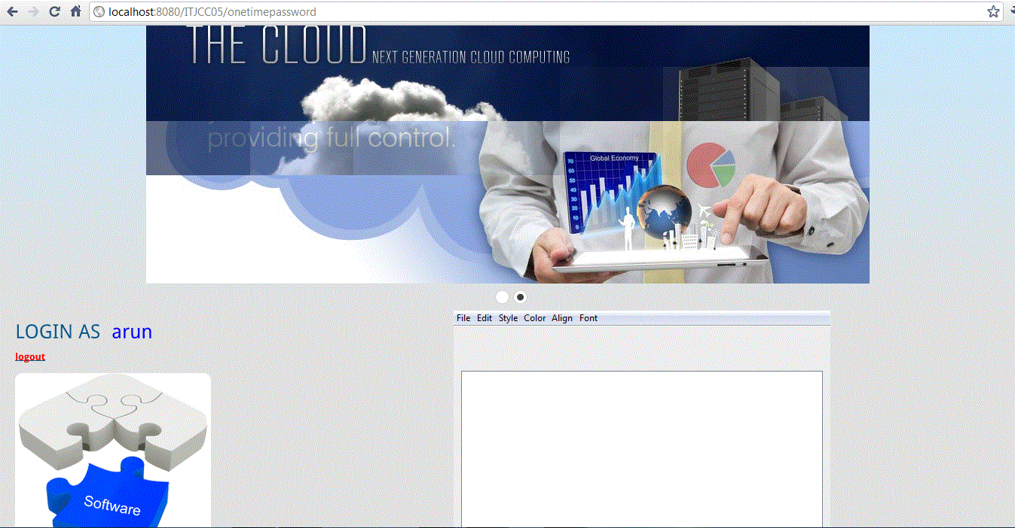

To send user SLA copy

